الاسم:عمر محمد محمود حسنين (2)
Chapter 4
- Which function in Python checks only at the beginning of a string (a)
- What does the regex pattern \d+ match (b)
- Which regex will match any string ending with "ing" (b)
- The output of re.findall(r"[aeiou]", "Python Programming") is (a)
- Which regex matches a valid variable name in Python (letters, numbers, underscores, not starting with digit) (a)
- The metacharacter ^ inside brackets [^...] means (c)
- What will be the result of: re.split(r"\s+", "Python is easy") (b)
- Which function is best for replacing substrings using regex (b)
- re.match() scans the entire string for a pattern (false)
10)The regex . matches any character except a newline (true)
11) Regex \w+ matches only uppercase letters (false)
12) The regex \d{3} matches exactly three digits (true)
13) re.sub() can be used for both searching and replacing (true)
14) Regex patterns in Python are case-sensitive unless re.IGNORECASE is used (true)
15) re.findall() returns only the first match found (false)
16) "Python" matches the string "I love Python" (true)

*short answer questions*
1) Differentiate between re.match() and re.search()
Answerre.match() checks for a match only at the beginning of the string. re.search() scans the entire string for the first location where the pattern matches.
2) Explain the difference between *, +, and ? quantifiers in regex
Answer* (Asterisk): Zero or more occurrences. + (Plus): One or more occurrences. ? (Question Mark): Zero or one occurrence.
3) What is the purpose of named groups in regex? Provide an example.
AnswerPurpose: Named groups allow you to refer to a matched substring by a name instead of its index, making the regex result easier to read and access. Example: (?P<name>\w+) (matches and names the matched word as "name").
4) Write a regex to match a date in the format YYYY-MM-DD.
Answer^\d{4}-\d{2}-\d{2}$
5) What does the pattern [A-Za-z0-9._%+-]+@[A-Za-z0-9.-]+\.[A-Za-z]{2,} validate?
Answer Email address
6) Why might re.split(r"\s+", text) be preferred over str.split()?
Answer re.split() can split on multiple delimiters or variable-length delimiters (like one or more spaces, \s+), whereas str.split() without arguments only splits on any single whitespace character.
7) Explain how re.sub() can be used for text normalization (e.g., removing multiple spaces).
Answerre.sub() can replace all occurrences of a pattern (like multiple spaces, \s+) with a single replacement string (like a single space, " "). Example: re.sub(r"\s+", " ", "text with gaps") results in "text with gaps".
*problems*
1) import re
pattern=r"^[\w\.]+@[\w\.-]+(\.com|\.edu|\.org)$"
2) 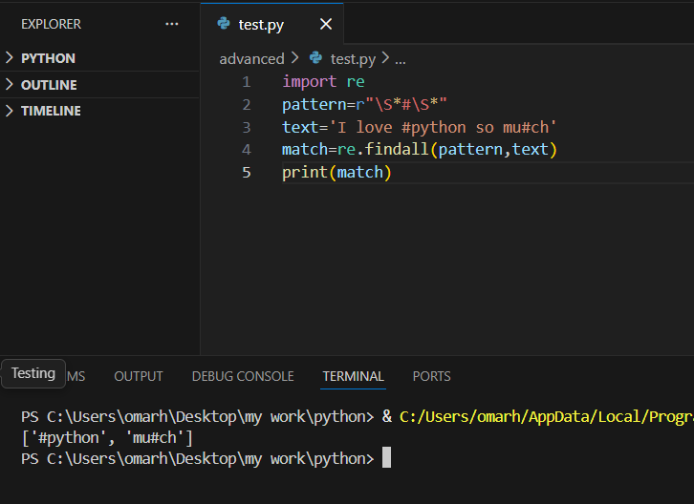
3)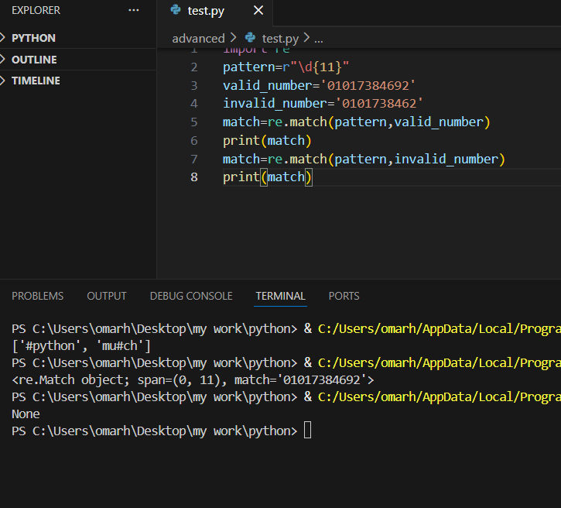

4)

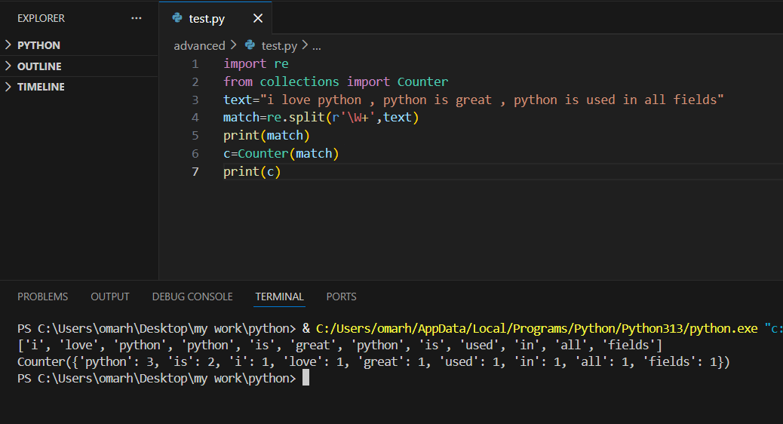
5) 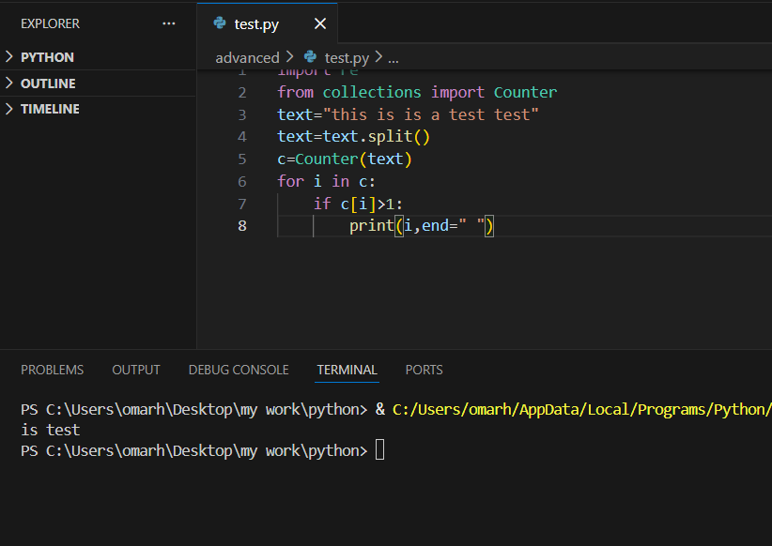
6) 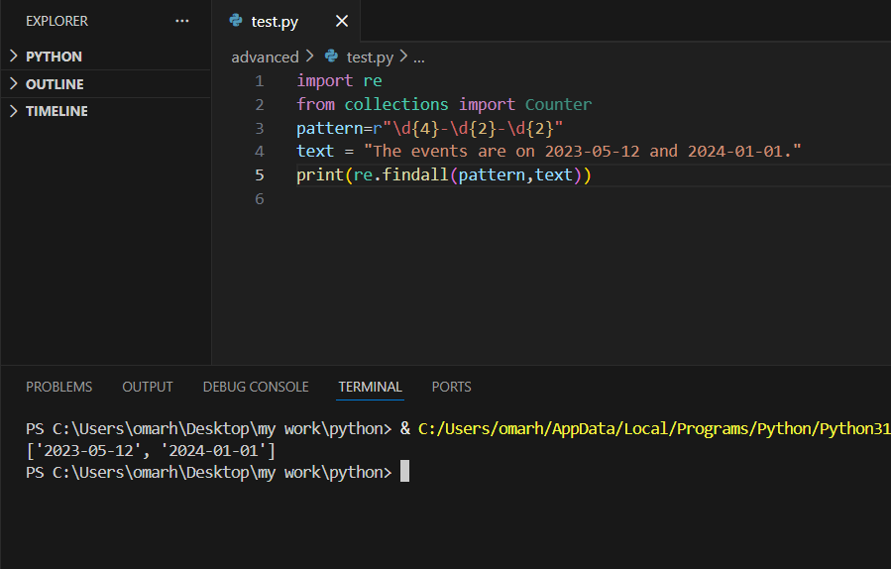
7) 